# INFORMATICS INSTITUTE

# ADIT PROJECT

**(IT 201)**

**OPERATING SYSTEM: WINDOWS XP**

## Full name: Joeven A. Valenzuela

Class: ADIT 1st Year Batch 3

Centre: Informatics Institute Robinson’s Place Imus

Country: Philippines

**TABLE OF CONTENTS**

Introduction and Objectives 3

Chapter 2: Installing Windows XP 4-19

Chapter 3: Microsoft Management Console 21-30

Chapter 4: Users, Groups, Profiles, Policies 31-38

Chapter 5: Back-up and Restore 39-49

Chapter 6: File Sharing and Security 50-55

**Introduction**

A computer will not run smoothly without its software. Microsoft launched the one of the users

–friendly operating system, the**Windows XP**. This will discuss the basic functions of **Windows XP**

operating system. It will explain to us how the Operating system perform and interact.

**Objectives**

With this Operating system, we can able to the following

* Explain the basic function of the **Windows XP**
* How to **install** and **repair** an Operating system
* Restricting commands or application using **gpedit.msc**
* How to create your **back up** files
* Create folder/s with **Sharing** and **Security**
* Managing Windows xp files system by **Microsoft Media Console (MMC)**

**Chapter 2: Installing Windows XP**

# 

# Press ENTER to set up Windows XP. The next screen that appears is the Windows XP Licensing Agreement screen. Read through the agreement and press F8 to confirm that you agree with the terms.

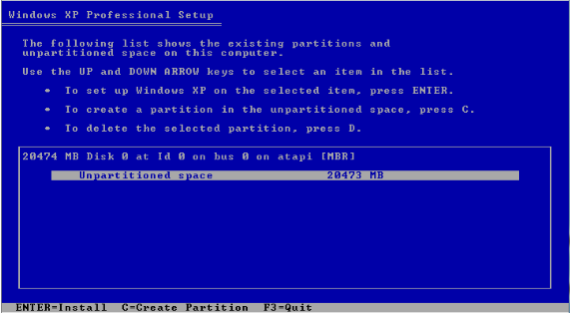

1. To create a partition, choose the unpartitioned space below then press **C** (this will become your Drive C:)

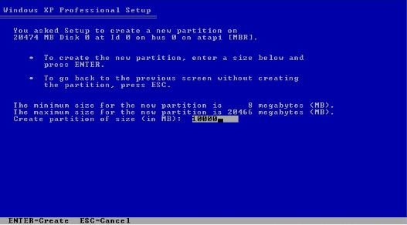

1. Create a partition size. It must be in **megabyte(MB)**.

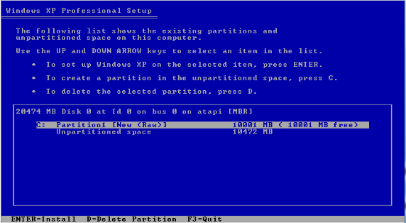

1. Drive C: has been created. Though you still have 10GB unpartitioned space, create another partition (this will become your Drive E:).

There will always be a relatively small amount of space left over that will not be included in the partitioned space. This will be labeled as Unpartitioned space in the list of partitions, as shown in the screen shot.

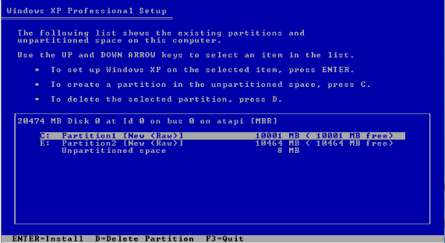

1. Now you have 2 partitions which is Drive C: and E:.Press **ENTER** to **Install**.

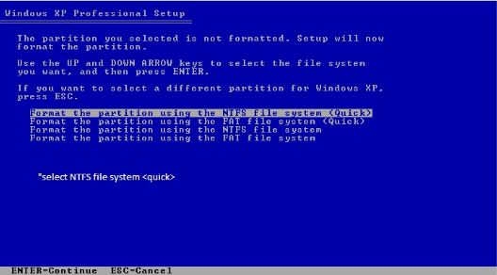

1. Choose NTFS file system <Quick> for fast formatting of your partition.

# 

# This loading bar shows the setup is formatting the partition you have made.

# 

1. The setup now is copying the files to the Windows installation folders.

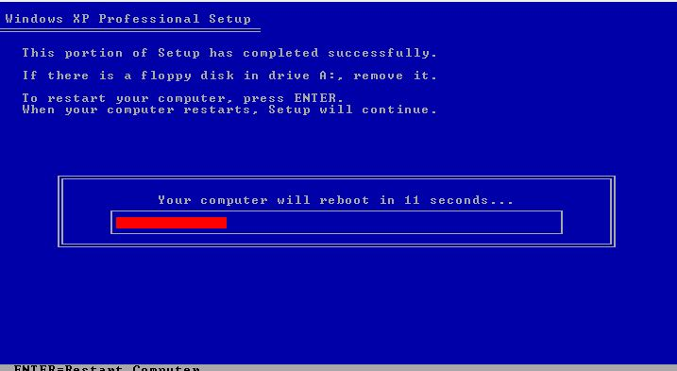

1. This portion of setup has completed successfully. We will now wait for the computer to **reboot.**

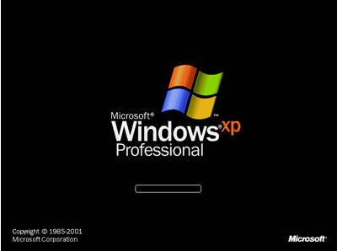

1. Microsoft Windows xp Professional will display. With its copyright and company.

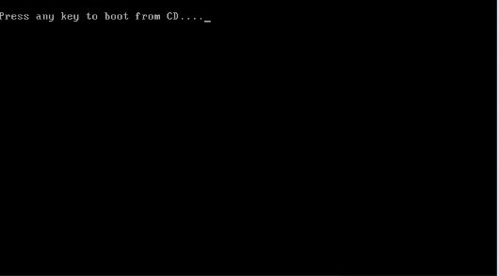

1. After **rebooting**, a black screen with “**Press any key to boot from CD…**” will appear. Don’t press any key.

Note: If you press a command your operating system will reboot again.

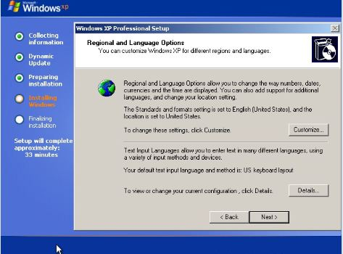

1. During installation, the Regional and Language Options window will appear. After you've made any changes, or if you've determined no changes are necessary, click **Next.**

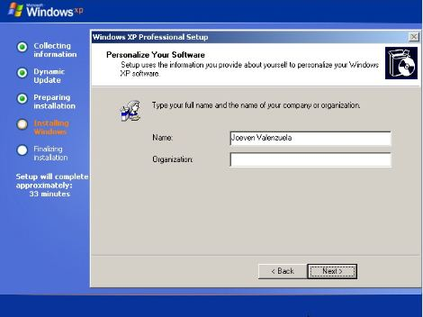

1. In the Name: text box, just type in your full name. In Organization: text box, just type in your organization’s name or business name.

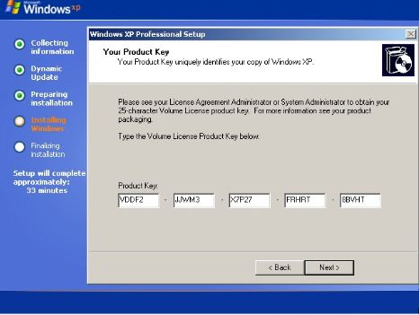

1. Your **Product key** uniquely identifies your copy of **Windows xp.** If you bought an original installer of **Windows xp,** you find your product key in the box.

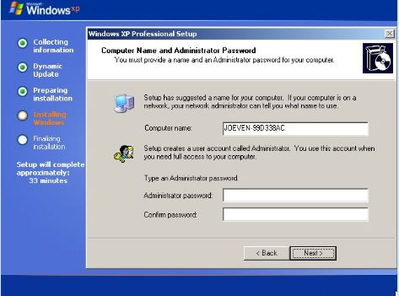

1. In the Computer name:**Windowsxp** setup has suggested a unique computer name for you. If your computer will be on a network, this is how it will be identified to other computers. In the Administrator password: enter a password for the local administrator account. This field can be left blank but it's not recommended to do so for security purposes. Click **next**when complete.

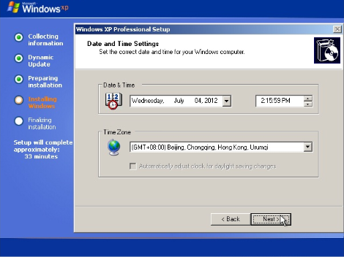

1. In **Date and Time Settings,** you can set your correct date and time according to your Time Zone.

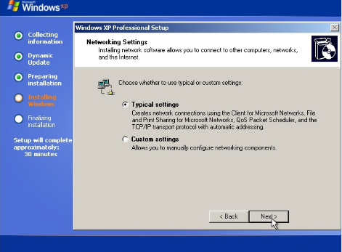

1. Networking Settings. Installing network software allows you to connect to other computers, networks, and the internet.

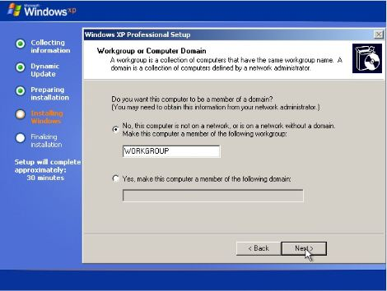

1. If you are installing **Windows xp**in a single computer just choose **NO,** then just leave the name “WORKGROUP” as a default name. Click **NEXT.**

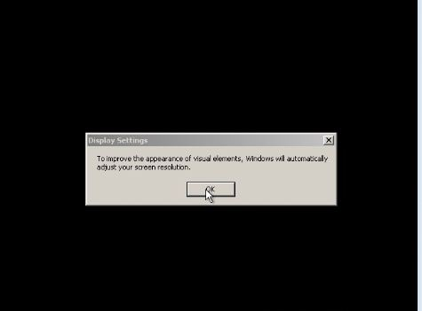

1. Press **OK** to improve appearance of visual elements. It will automatically adjust your screen resolution.

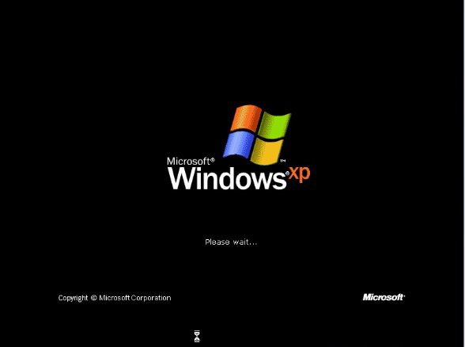

1. The opening screen for Windows xp is now loading. Please wait until the loading screenhas finished.

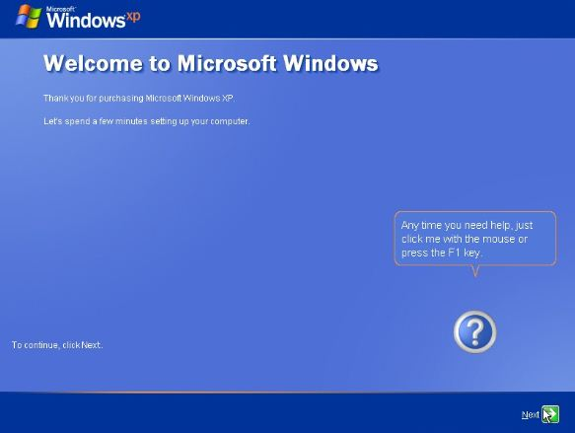

1. It will take a few minutes to setup your computer. To continue, click **Next.**

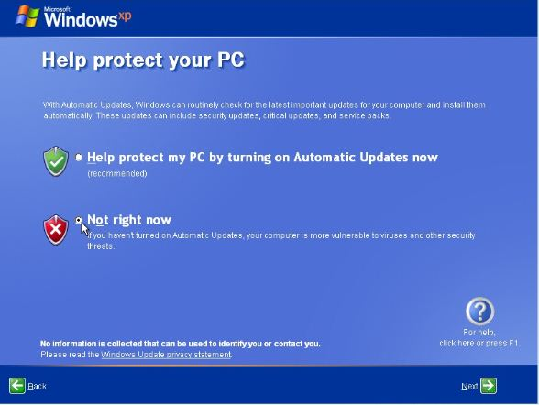

1. If you install a not genuine Windows xp, You should choose **No right now.** Then click **Next**

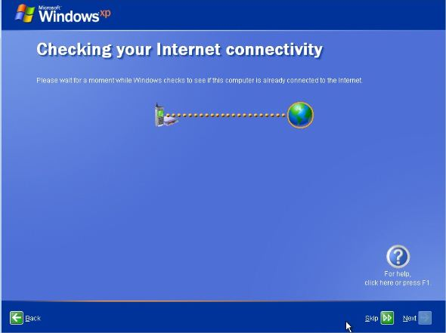

1. The computer checks to see if the computer is already connecting to the internet. You can Skip or you can wait.

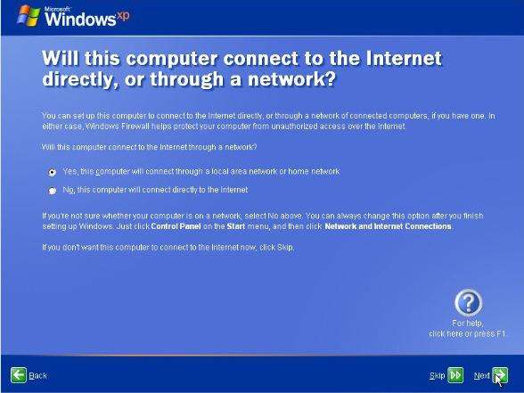

1. Your computer will ask you if you want to connect to internet directly or through a network. If you already had an internet in your home,choose**NO.** If you want to connect through LAN or home network, choose **Yes.** Then click **Next.**

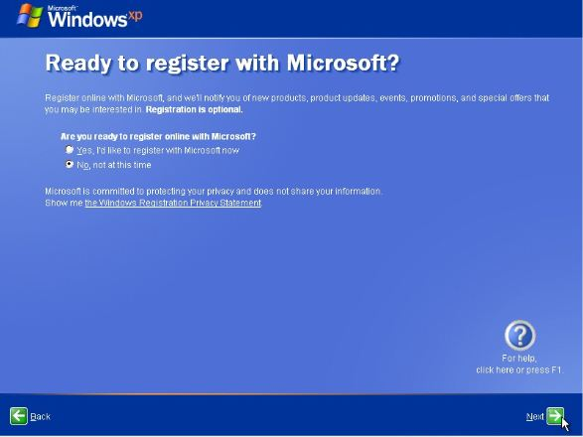

1. Registration with Microsoft is optional, but if you'd like to do that now, choose **Yes, I'd like to register with Microsoft now**, click **Next**and follow the instructions to register. Otherwise, choose **No, not at this time** and click **Next.**

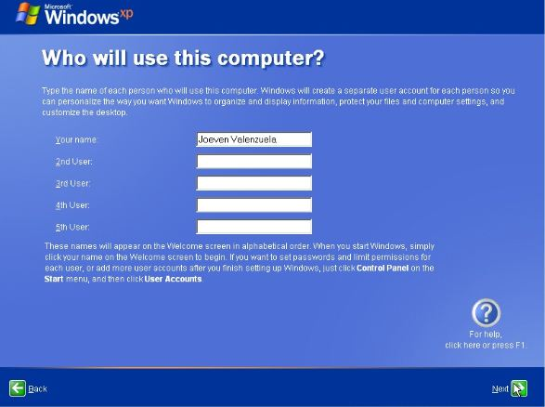

1. In this step, setup wants to know the names of the users who will use **Windows XP** so it can setup individual accounts for each user. You must enter at least one name but can enter up to 5 here. More users can be entered from within **Windows XP** after installation is complete.

After entering the account name/s, click **Next** to continue.

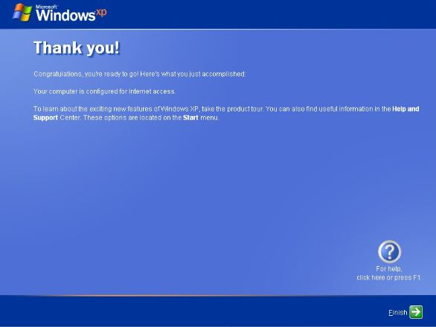

1. All of the necessary files are installed and all of the necessary settings are configured. Click **Finish** to proceed to Windows XP.



1. **Windows XP** is now loading for the first time. This may take a minute or two depending on your computer's speed.

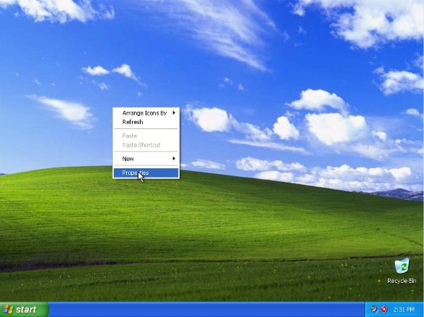

1. This completes the final step of the Windows XP clean installation! Congratulations! If you want to appear the icons on your desktop, right click then Properties.

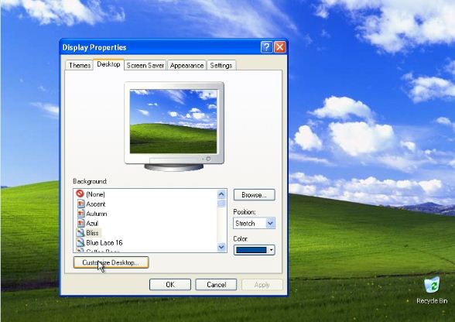

1. Go to Desktop then Cuztomize Desktop.

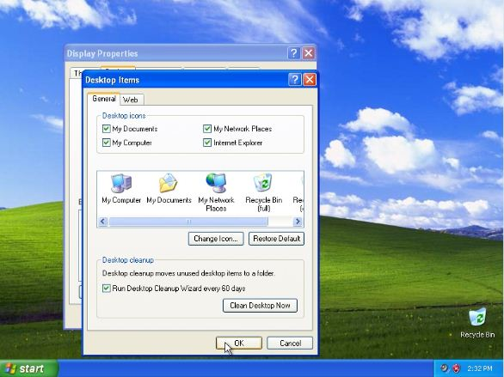

1. Check the boxes then click **OK.**

**Chapter 3: Microsoft Management Console (MMC)**

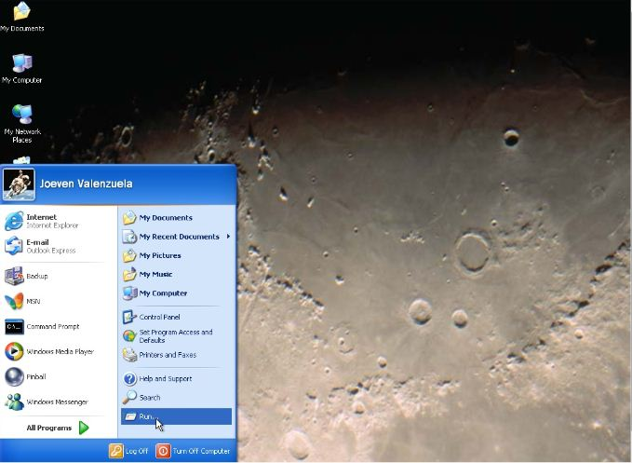

1. To run MMC , first you must click the start menu/button then go to “Run..”

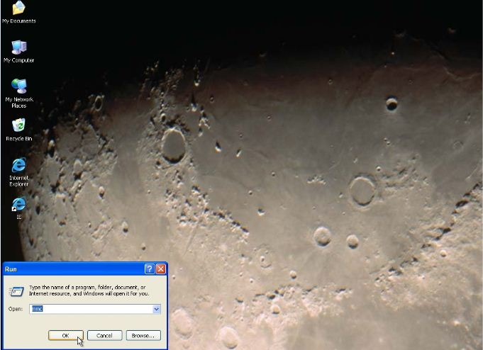

1. Type “mmc” then press ok.

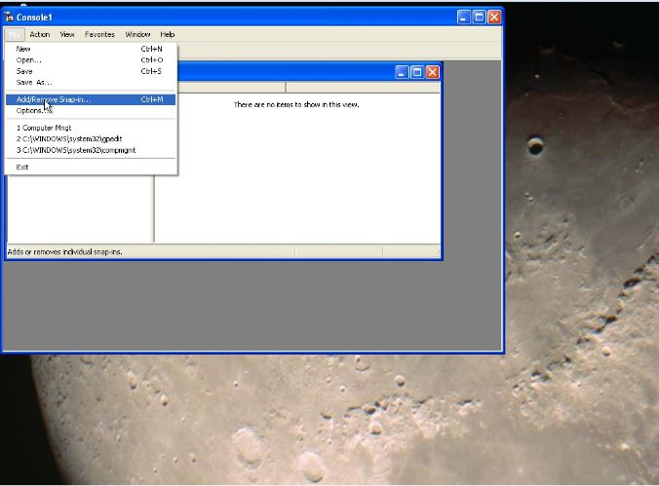

1. Click file and click Add/Remove Snap-in.

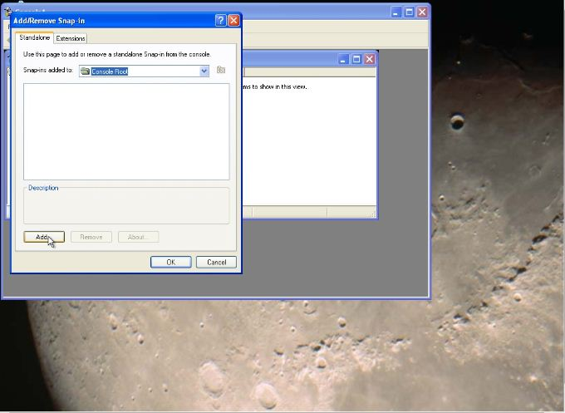

1. To add snap-in, Click Add.

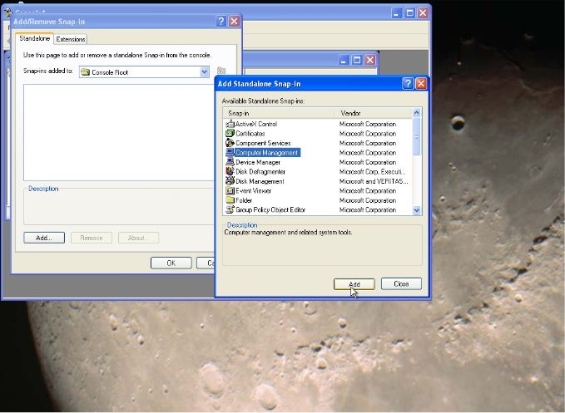

1. Choose some available standalone snap-ins. Then click add.

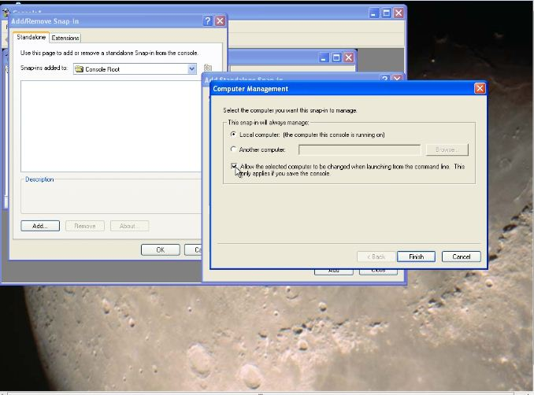

1. After choosing a standalone snap-in. You will check the box that will allow the selected computer to be changed when launching from the command line. Then click finish.

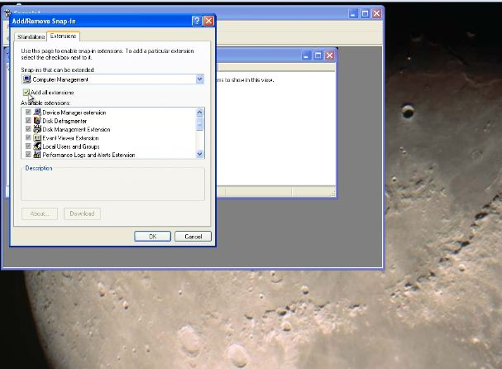

1. Go to extensions; uncheck the box to add all the extensions.

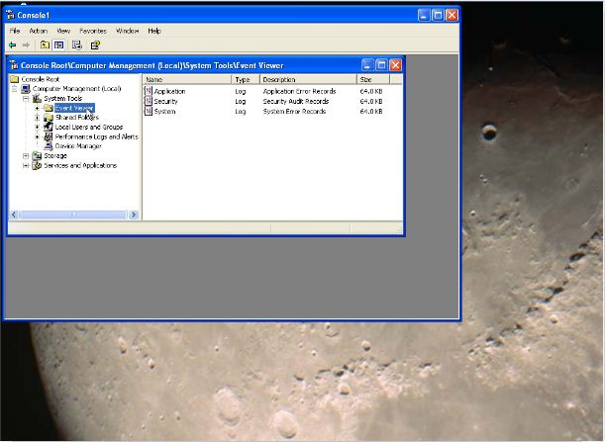

1. Go to computer management. Click system tools then go the Event Viewer Folder.

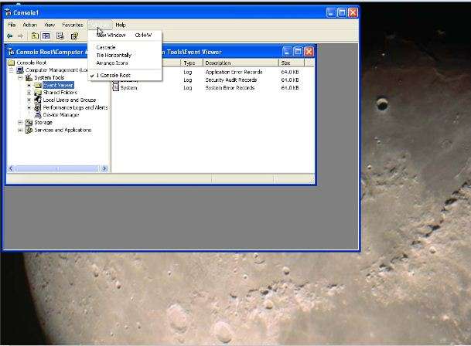

1. Click the windows button then open a new window.

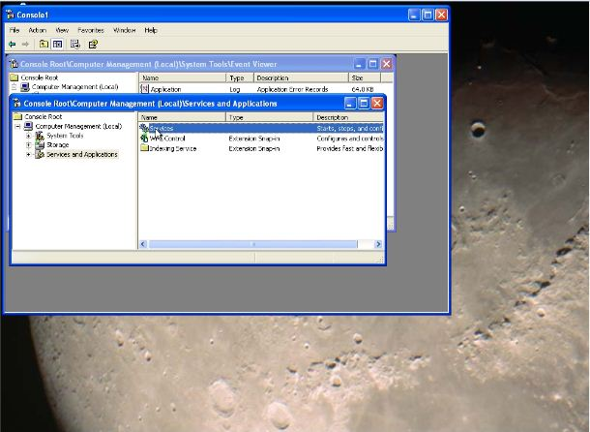

1. Under computer management, click services and applications then go to services.

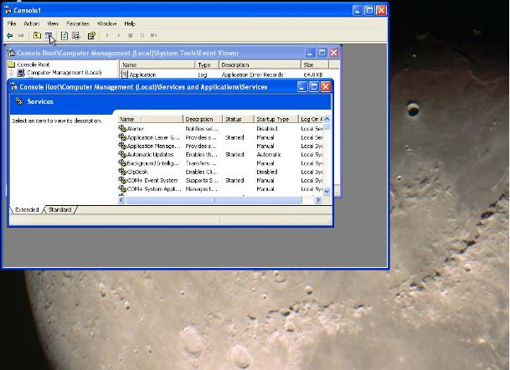

1. After viewing the services window

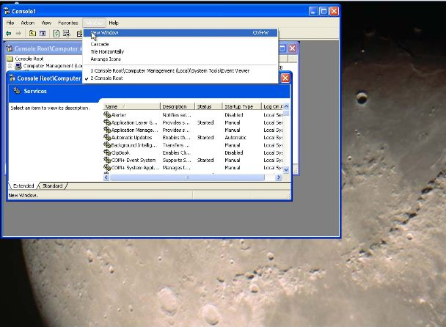

1. Open a new window.

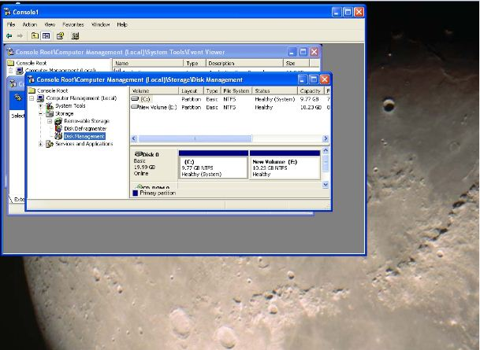

1. Under computer management, go to disk management. In this window, it will give a view to your disk drives.

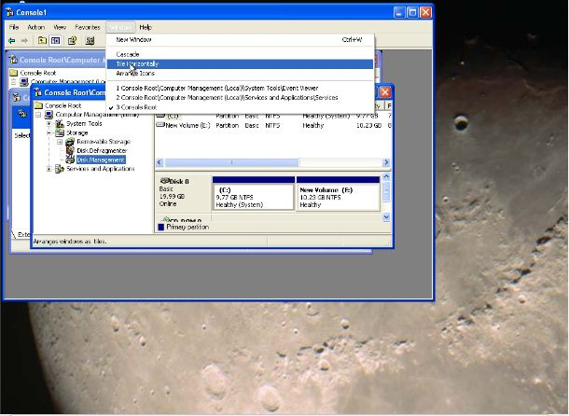

1. Go to window tab, and then arrange the tile horizontally.

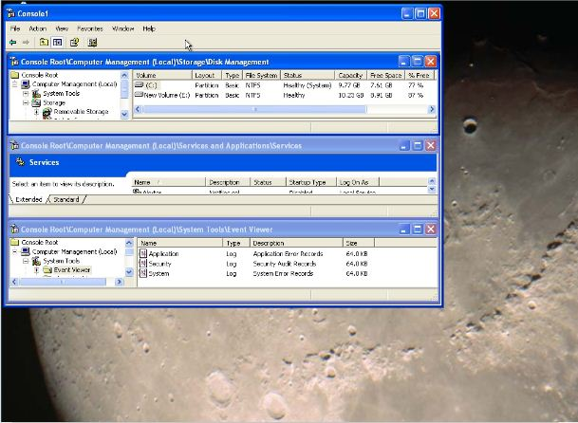

1. After arranging the tiles.

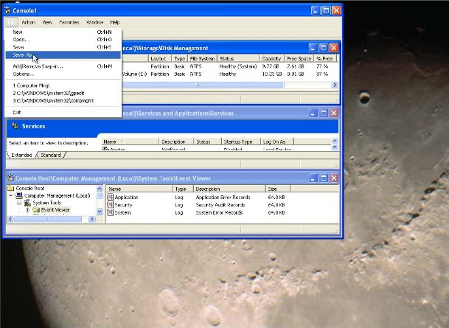

1. You can now save your work in your desktop.



1. Users console has been made.

**Chapter 4: Group Policy Edit (gpedit.msc)**

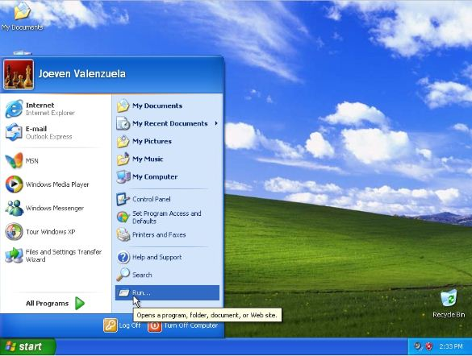

1. To start gpedit.msc, go to start menu then click Run…

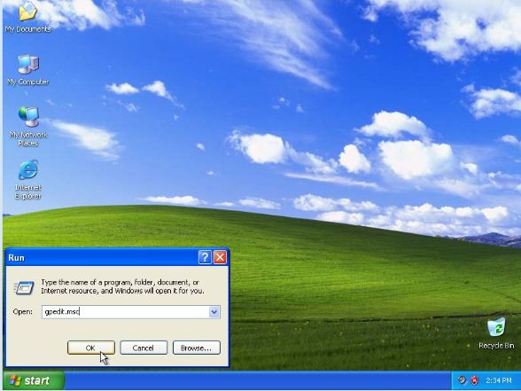

1. Type gpedit.msc then click ok.

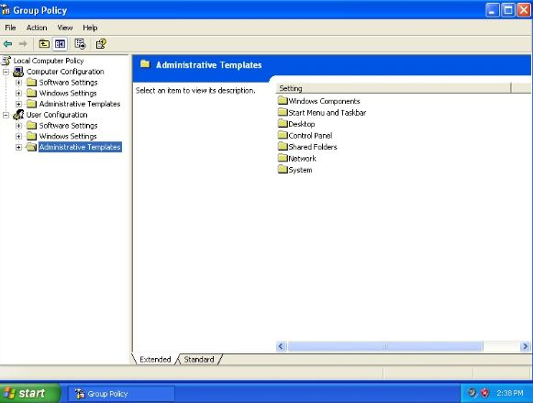

1. Go to the folder of Administrative Template.

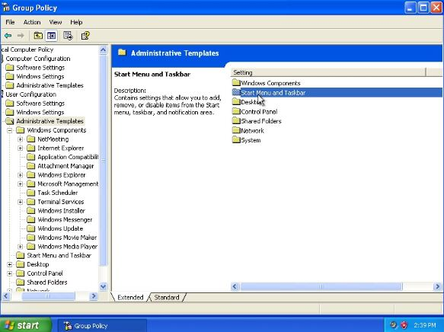

1. Go to Start Menu and Taskbar.

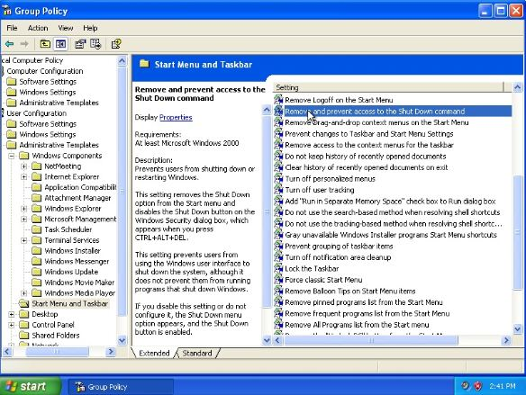

1. Click Remove and Prevent access to the Shut Down command.

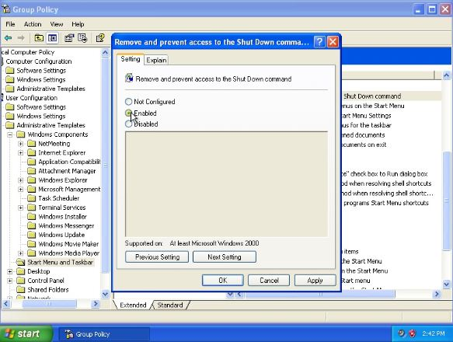

1. Choose Enabled then click OK.

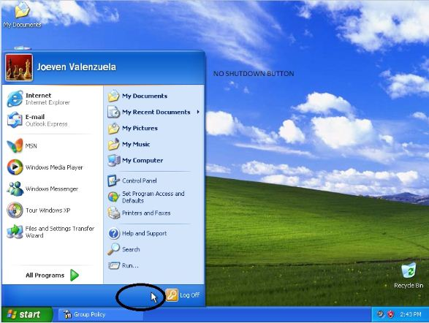

1. The Shutdown button is gone.

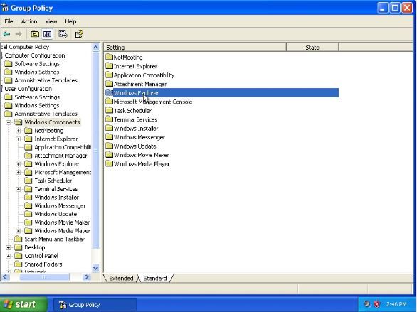

1. Still under Administrative Components, go to Windows Explorer

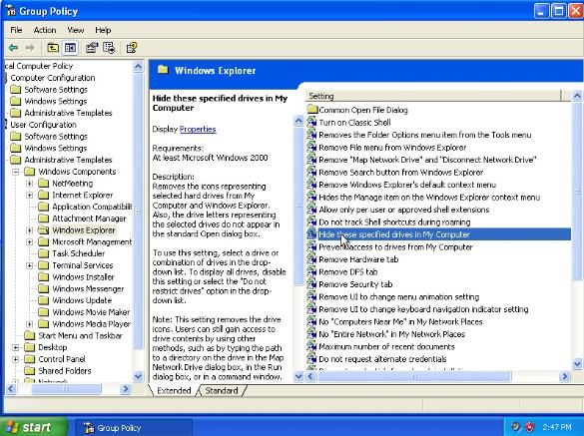

1. Double click hide these specified drives in My Computer.

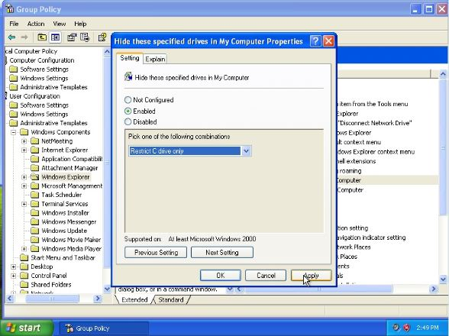

1. After choosing enabled, a window will pop out and you choose which drive are you hiding. Then click apply.

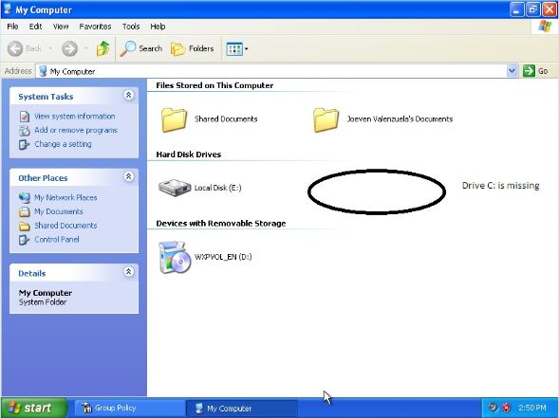

1. Now the drive C: is now missing.

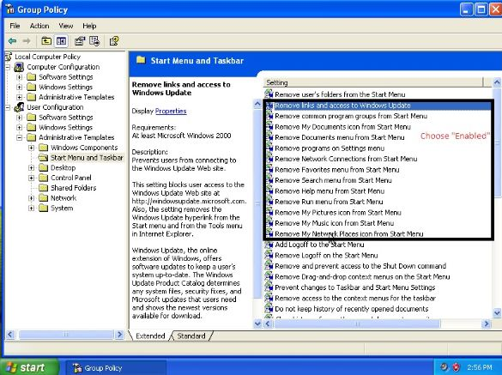

1. Under Start Menu and Taskbar folder, Enabled the one that are in the box.

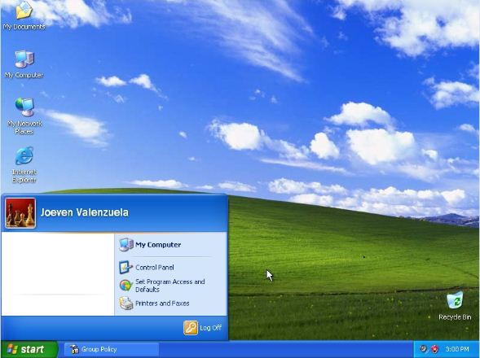

1. After clicking enabled, other applications under Start menu are gone.

**Chapter 5: Back-up and Restore**

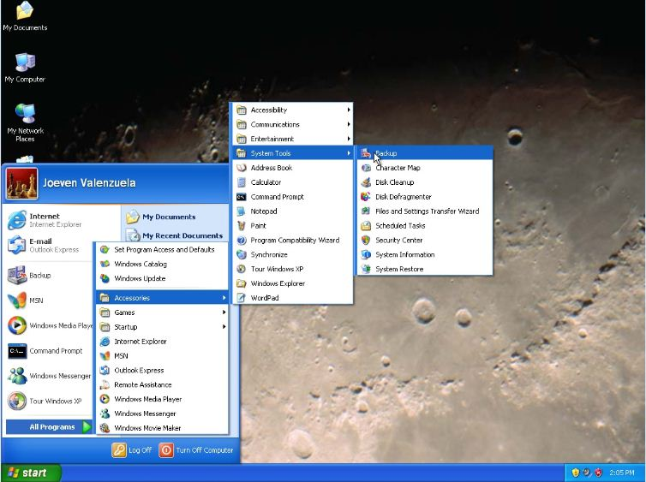

1. Go to Start Menu, Go to Accessories, System Tools and go to Back up.

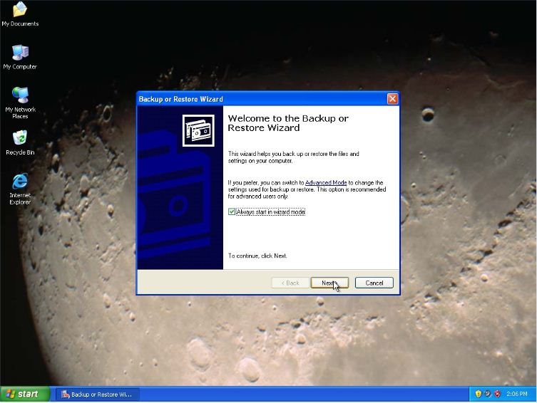

1. A back up or Restore Wizard will pop out, Click next.

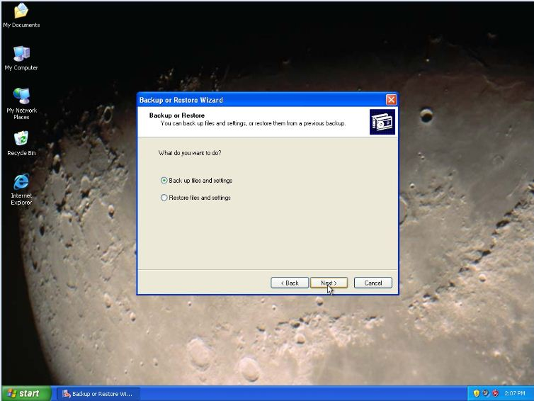

1. It will ask you what to do, choose back up files and settings. Then click next.

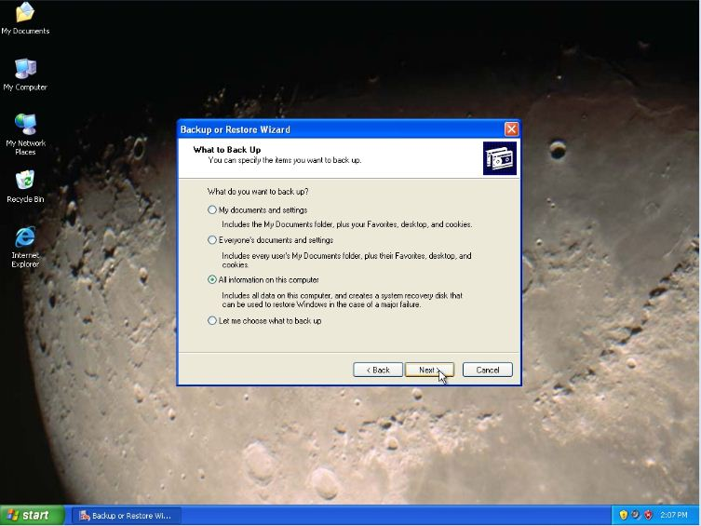

1. It will ask you again what items you want to back up. Choose “All information on this computer. Then click next.

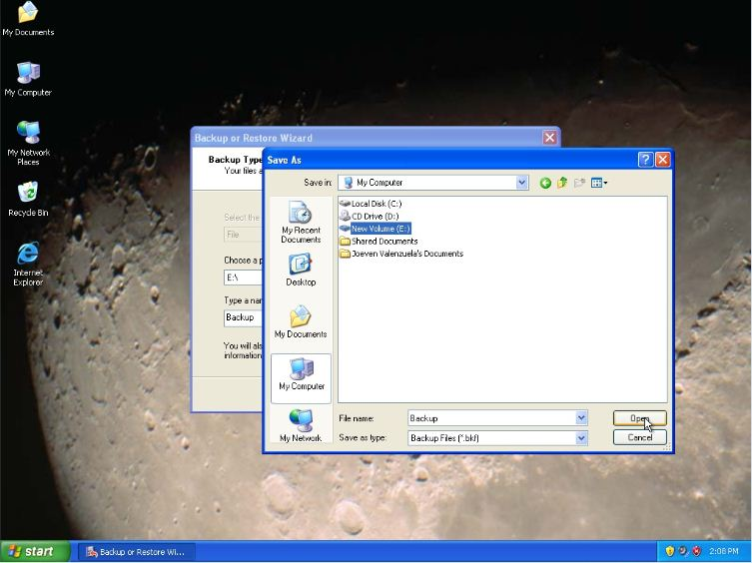

1. Choose what drive you want to back up, and then click open.

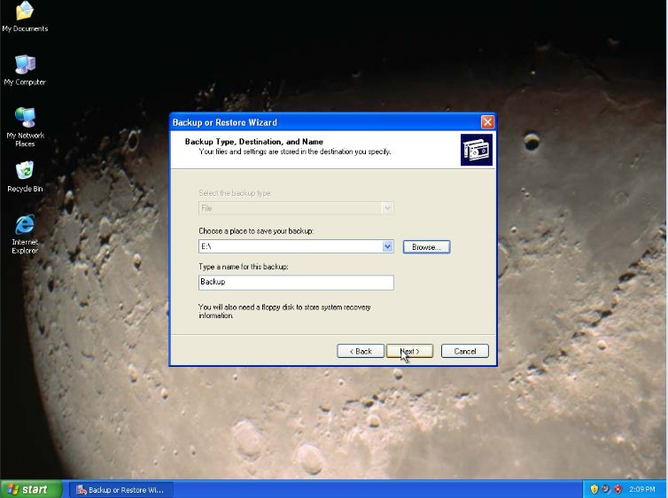

1. Your files and settings are stored in destination you specify.

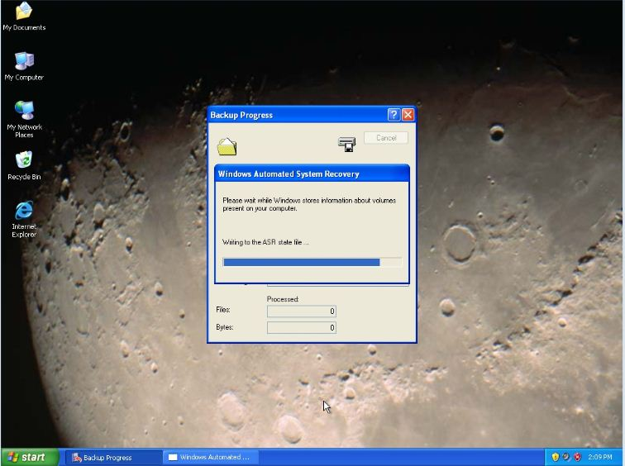

1. Please wait while the windows stores information.

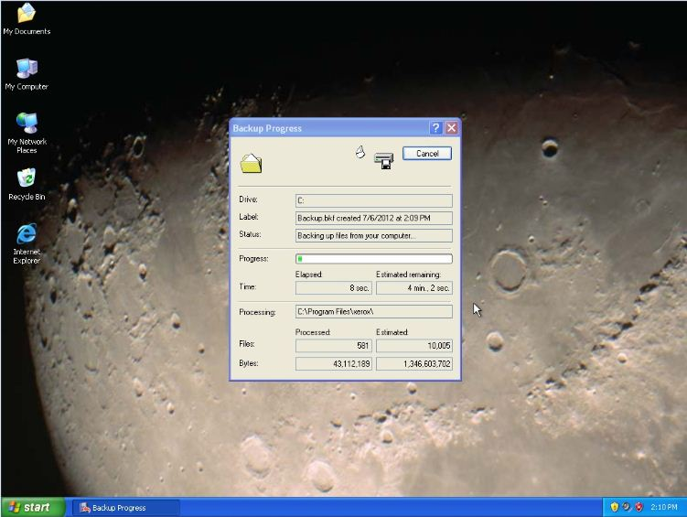

1. It will take a while to back up your files.

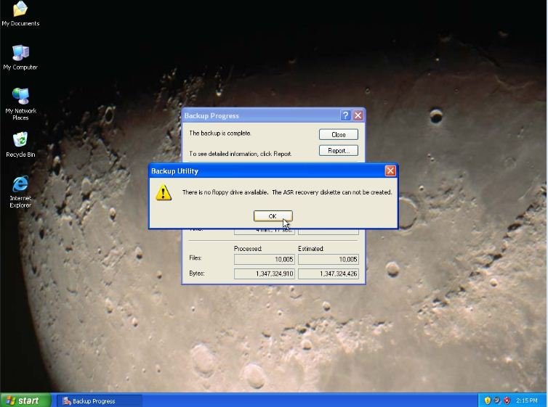

1. If your computer does not have a floppy drive, it will give you a notice. Just click OK.

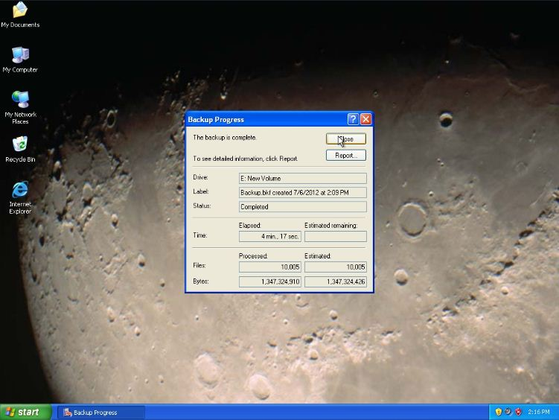

1. Your back up is finished.

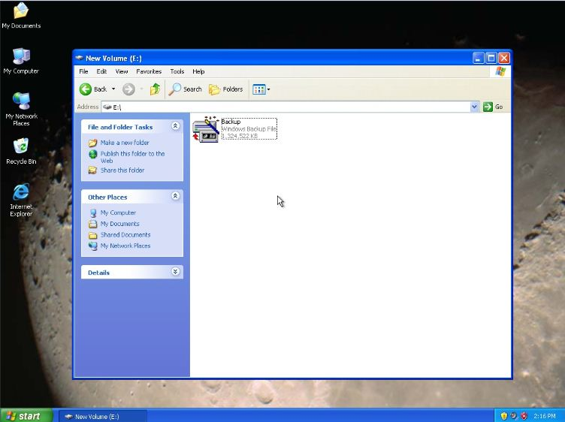

1. You can check your drive where you put your back up files.

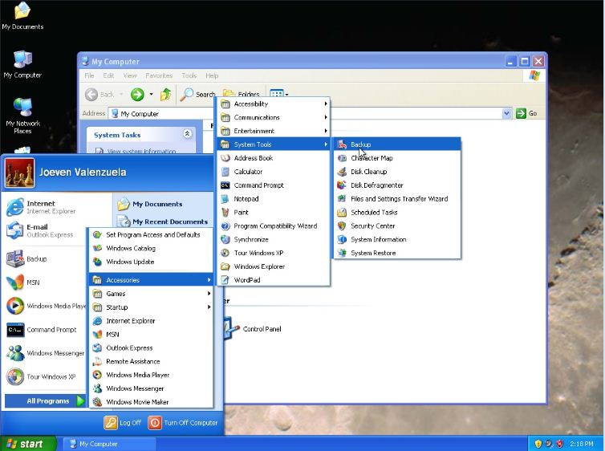

1. Same procedure as the you back up your file.

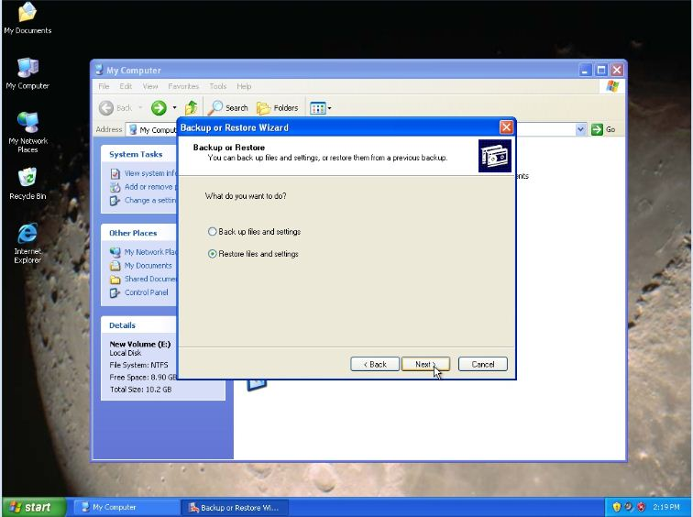

1. Choose restoring files and settings and click next.

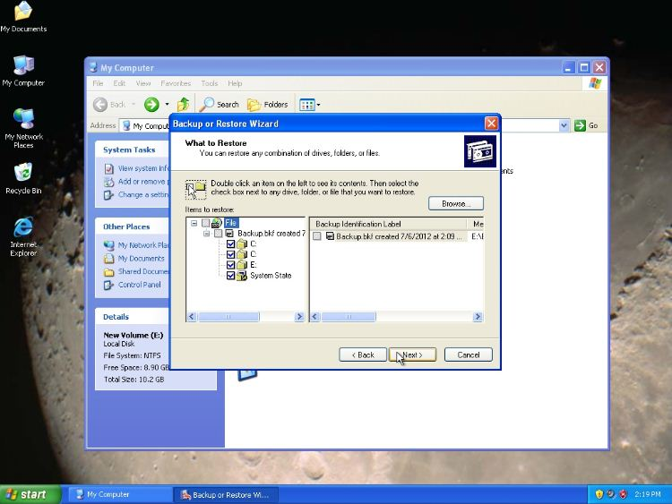

1. Double click an item on the left. Then check all the drives that you back up.

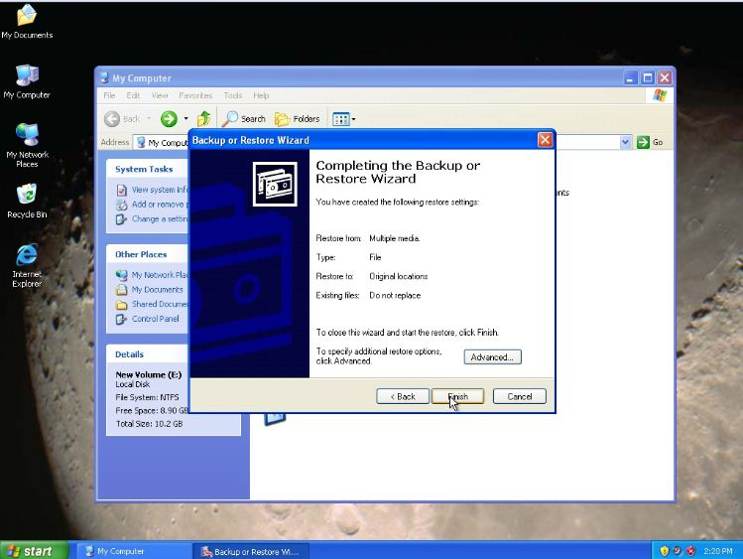

1. After creating the following restore settings. Click finish.

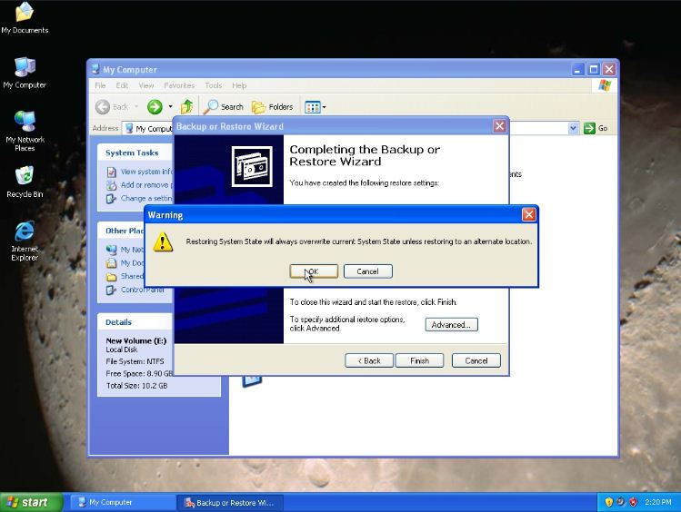

1. It will always overwrite the current system. Then press ok.

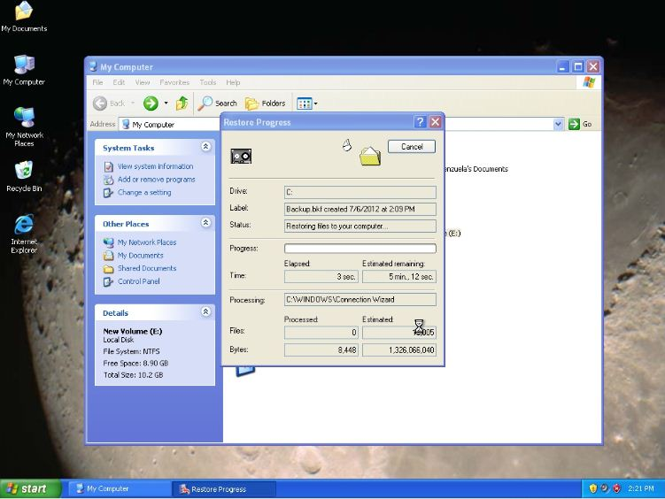

1. It will a few minutes to restore your files.

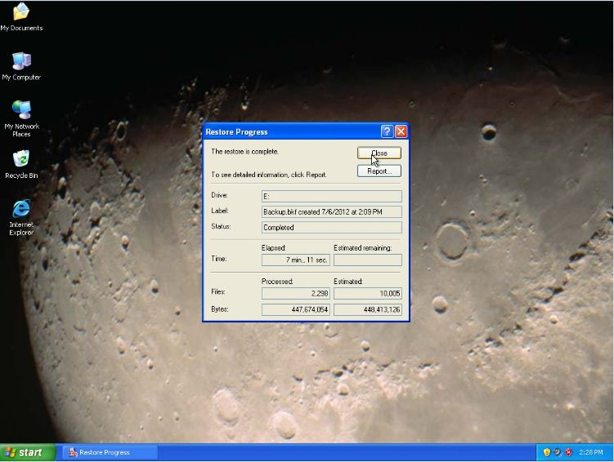

1. The restoration is complete, Press close.

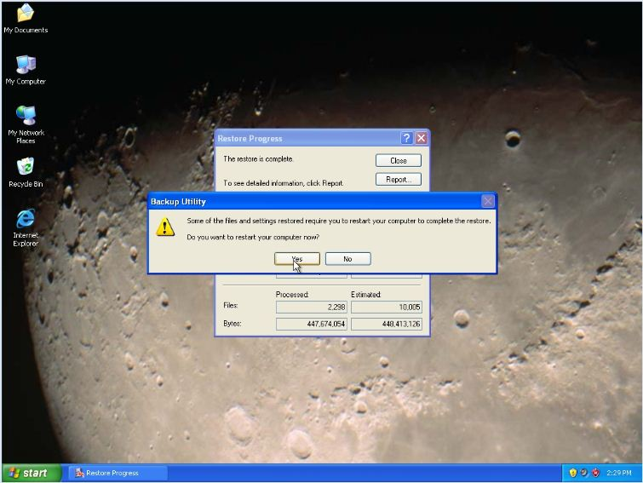

1. After restoring your files, the computer will ask you to restart your computer. Click ok.

**Chapter 6: File Sharing and Security**

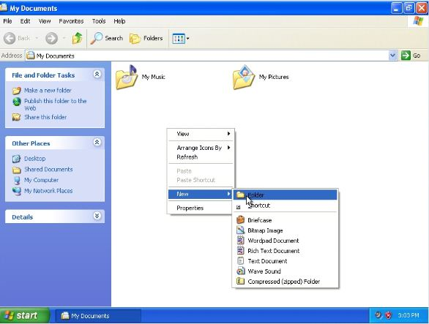

1. In your “My documents”, Create a new folder.

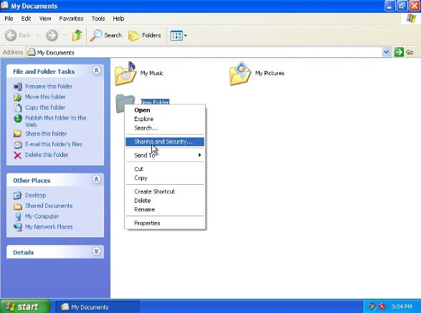

1. Go to your empty folder then right click. Click sharing and security.

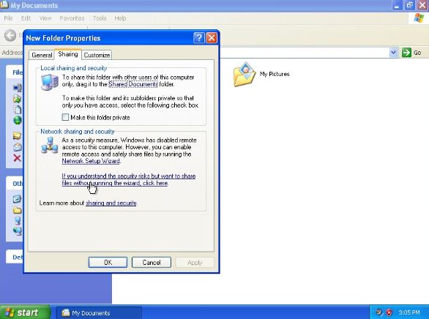

1. Go to sharing tab, under Network, sharing and security link that will tell you to share files without running a wizard.

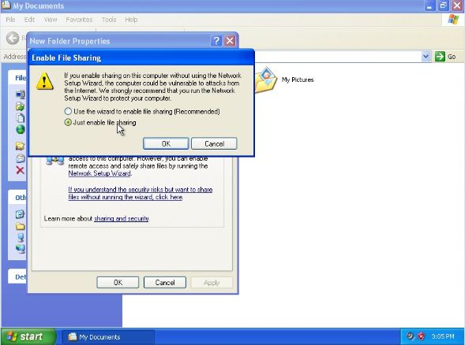

1. Choose Enable file sharing then click ok.

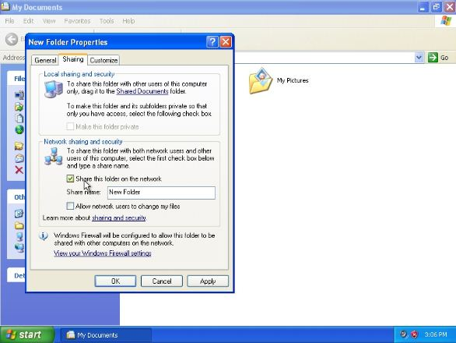

1. Under sharing, check the box, then put a share name folder and click apply.

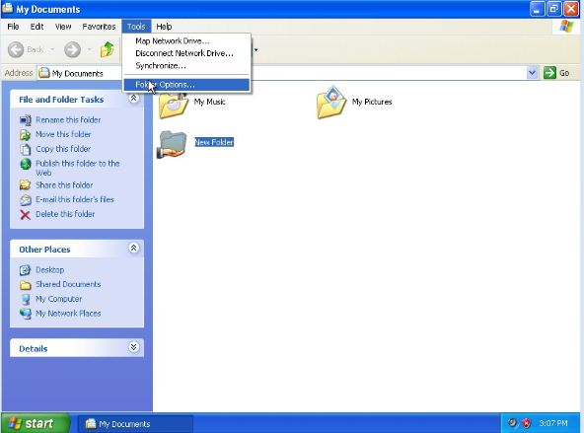

1. Highlight your folder and go to Tools then click folder options.

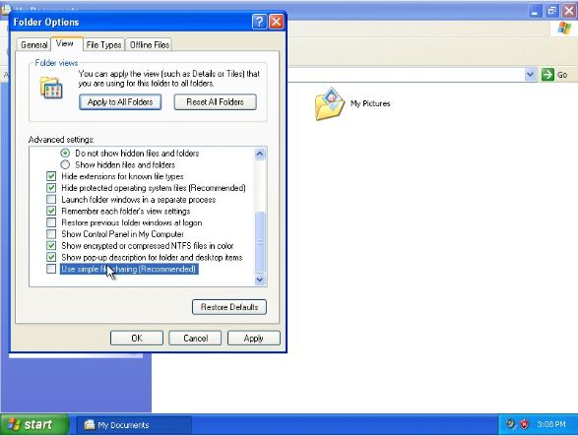

1. Go to view tab and scroll down, uncheck the box that says “use simple file sharing”.

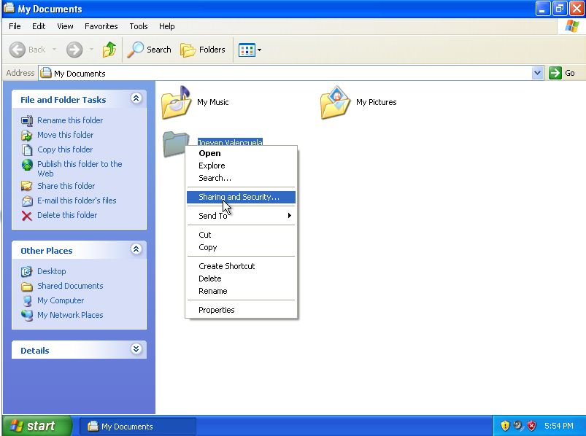

1. For security, right click then sharing and security.

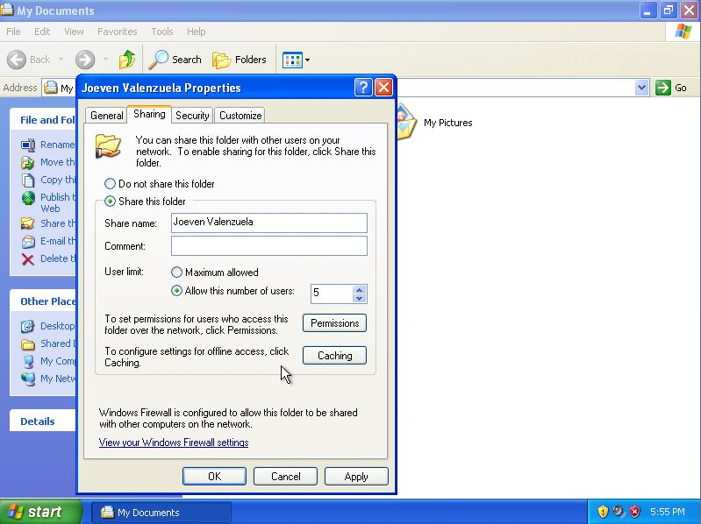

1. Click share this folder, and choose a user limit.

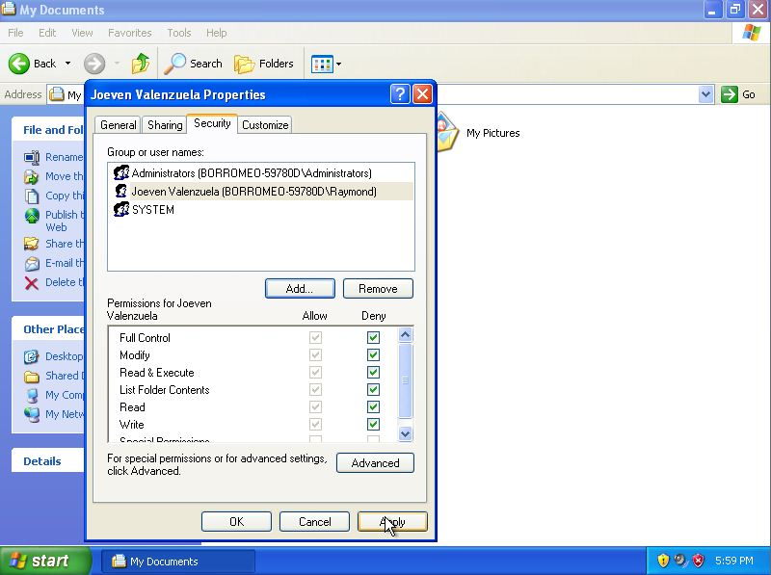

1. Go to Security tab and Check the entire box. It will deny full control from the other users except the administrators